ST MARGARET’S
Parish Church for Leiston-cum-Sizewell

(More details about these kneelers on page 7)

OCTOBER 2020 £1
£1

SERVICES ON SUNDAYS AT ST MARGARET’S CHURCH

10 am Holy Communion (Said service)

All welcome

In addition to these services, recorded services with members of the church leading prayers, giving Bible readings and a Homily are available via the internet. If you wish to receive these services please contact the Vicar.

CONTACT US

Priest in Charge: Reverend Richard Finch: T.830421
The Vicarage, Church Road, Leiston E.vicarleiston@gmail.com
Associate Priest: Reverend Morag Finch
Reader: Mr Bernard Smith: 3 Daneway Gardens, Leiston T.830105
Lay Elders:
Mrs Pat Carter, 42 Haylings Road, Leiston T.831852
Mrs Sandra Harle: 4 Lime Tree Avenue, Leiston T. 833578
Church Wardens:
Mrs Pat Carter: 42 Haylings Road, Leiston T.831852
One Vacancy
PCC Treasurer: Mrs Sandra Harle: 4 Lime Tree Avenue, Leiston T. 833578
PCC Secretary: Mrs Pat Carter, 42 Haylings Road, Leiston T.831852
‘JAM’ (Jesus & Me) Sunday School Leader: Mrs Sandra Ellis T.832168
Organist & Choir Master: Mr Matthew Merrett
Deanery Synod Representatives:
Two Vacancies
Resident Retired Priests:
Reverend Richard Ellis: 9 Kings Road, Leiston T.832168
Reverend Pauline Florance: 1 Woodlands, Leiston T.768124
Reverend Jim Florance: 1 Woodlands, Leiston T.768124
Website Editor: Mrs Maureen Fox T.830929
Magazine Editor: Mrs Pat Carter T.831852 Email: pm42carter@gmail.com

Thanksgiving …
“When you reap the harvest of your land, you shall not reap to the very edges of your field, or gather the gleanings of your harvest..” (from the book of Leviticus, chapter 19, verse 9).

There are many rules about life in the Old Testament book called Leviticus. Many of the rules seem logical, some don’t make any sense to our modern living. The one that I have quoted made a lot of sense to the people of Israel in those early days especially in the story of Ruth.

Naomi returned to Bethlehem from the land of Moab with her daughter-in-law, Ruth. All the rest of Naomi’s family had died. They had little to live on and Ruth went out to get what she could from the fields after the crops had been harvested. The rules of not reaping to the edges of the field and not gathering the gleanings meant that there was some left for those who were struggling. The owner of the field, Boaz, saw the care that Ruth had for Naomi and … you will have to read the book (called Ruth) for what happened next.

Harvest celebrations in St Margaret’s Church have been adapted this year. On Sunday 4th October instead of surrounding the altar with food as an expression of thanksgiving we are creating a banner with pictures and memories that people have left in the church and displaying flowers. Two aspects of our Harvest celebration have not changed; thanksgiving and awareness.

Thanksgiving – we are thankful for the wonder of our planet, the goodness of soil, wind, sunshine and rain. We are thankful for those who raise crops and animals so that we have plenty to eat.

Awareness – we are aware of the fragility of nature and encourage people to do what they can to reduce pollution and to care for the world around us. We are also aware of people who are struggling, just like Naomi and Ruth those years ago, and encourage giving to those in need. The Foodbanks are doing what they can to provide essential provisions – there are collection points for donations in the Co-op store in Leiston and in Waitrose in Saxmundham. Awareness also means that we are inspired to take action to protect our wonderful world. There is enough to care and share across the world so that the world is protected and people do not go hungry.

Although our daily lives may be different this year, we can still give thanks for, and be aware of, the world around us.

May God bless you and keep you.

From Rev Richard Finch
++++++++++++++++

Link to Hope Shoebox Appeal
Helping to rebuild lives and communities in Eastern Europe
Following on from the leaflet enclosed in last month’s magazine, we very much hope that you will be able to support this year’s Appeal by either making up a shoebox of your own or by donating items for boxes which we, at St. Margaret’s, will put together.

You will see from the picture that we are already off to a good start thanks to Vi Matthews who has very kindly spent the last few months knitting lots of colourful hats and scarves to include in the boxes. Many thanks too for those of you who have already given financial donations.

The boxes need to be delivered to either Bungay or Hadleigh in early November. Therefore, I would be most grateful if you could either bring your contributions to church or deliver them to my house – 4 Lime Tree Avenue – before the end of the month. Or, if you would prefer, I can collect from you – please ring me on 833578.
In the meantime, if you need more leaflets or any further information, please let me know. Or visit the charity’s website – www.linktohope.co.uk – to find out more about its work and also to discover crafting ideas for aprons, bags, knitted headbands and all manner of other items that you could make to put in your shoeboxes.

With thanks, Sandra Harle

Pondering Prayer

“My God, my God, why have you forsaken me?” (Psalm 22:1)
There are times in most of our lives when we may be in despair; when everything around us seems to be going wrong. Work, family, partner, bereavement, or even what is happening in the world at large, and we start to wonder and ask the question, “Where is God? Why am I suffering like this?” Perhaps angry with God because he seems to have left our side. Why me? Are we allowed to be angry with God? Are we losing our faith in Him altogether?

The author of Psalm 22 knew what it was like to feel forgotten or even betrayed. Did Jesus on the cross have such feelings as he hung there in pain? In his Gospel Matthew tells us that Jesus cried out ‘My God, my God, why have you forsaken me?’ It is likely, as Jewish scripture, He probably learned the Psalm off by heart as a child and He now offers it up to his Father as a prayer of anguish. Is Jesus now doubting His own work? Has He misunderstood His mission? ‘Where are you Father?’ he calls. Remember too that in Gethsemane he prayed ‘if it be you will, take this cup from me’. Fear enters his mind.

Verse 2ff: ‘I cry to you and there is no answer – in the night no respite – abused by everyone, scorned by the people – all who see me jeer at me’. The tone of the Psalm changes. “He threw himself on the Lord for rescue; let the Lord deliver him, for he holds himself dear.” (v8) Verses that follow are like a prayer from someone in the throes of crucifixion ‘Do not remain far from me’; ‘my mouth is dry, my tongue sticks to my gums’; ‘my strength breaks away like water and all my bones are racked’: They share out my clothes and cast lots for my garments.’ Just like the gospel description of Jesus’ crucifixion.
At verse 19 the anger and pain lead to prayer. ‘But do not remain far away, Lord, you are my help, come quickly to my aid......’ A prayer of despair and as the Psalmist continues God answers. Read the next few verses as hope is regained and again there is much that relates to the life of our Lord Jesus. ‘But I shall live for His sake: My descendants (following generations of nations?) will serve him (Jesus?). The coming generation will be told of the Lord, they will make known his righteous deeds, declaring to people yet unborn: ‘The Lord has acted.’ Isn’t that just what Jesus’ followers and the Gospel and New Testament writers wrote?

The Psalm was written centuries before the birth of Jesus, yet in its depth is the story of the cross. It is also a prayer and could be ours as we take all things to God in prayer and patiently await His reply.

When you have time, read through the Psalm. Use parts of it as a prayer when it suits your needs, particularly in anger or despair. It may not happen at once, but God our Father will never leave us and He will answer, but not always in the way we expect.

Br. Christian

OCTOBER
Although we can mix a little more now, things do change so I still get a bit confused about mixing. Speaking to my friend in the USA a few weeks back, she said with masks etc. She feels as if she is going to rob the store instead of getting groceries. We got talking about us as small children having to carry gas masks. Every week in the class, we had a drill putting them on as they had to go all over your face and head. This meant once a week sitting for about thirty minutes while the eye visors got steamed up and misty; quite frightening for five year olds but we had to do it. When the air raid sirens went off we had to file onto the Recreation Ground into the shelters. Luckily they were mainly false alarms but one time it was for real. My cousin Michael got told off because he came into the shelter with me and he should have gone with the boys. He was really upset as he was always with me, like a brother really, he speaks about it even now.
Imagine how our parents felt, with men away in the Army or doing war work. The children were in the air raid shelter with younger brothers and sisters. Nothing they could do, but then again it was a false alarm. At least we knew who the enemy were, but now with Covid-19 it’s like something waiting to pounce. Everywhere looks normal but it’s not. All we can do is to take each day as it comes and although it’s autumn we do sometimes have lovely weather. We keep our faith in the Lord and He will give us strength to get through these times. MARGARET CLARKE
NO SORE KNEES AT THE CATHEDRAL!
On a recent visit to St Edmundsbury Cathedral (our first, I’m ashamed to admit), Philip and I were particularly interested in the wonderful array of kneelers displayed on the pews. The story behind them is as follows:

In 1963, a project was launched at the Suffolk Show which captured the imagination of every parish in Suffolk. Each was asked to produce two or more of the one thousand kneelers needed in the Cathedral. Each kneeler was to include the Christian symbol of the y-cross stitched in red and gold on a blue background which would represent Suffolk cloth. One was to show the dedication of the church and the other a local theme. Schools, hospitals, air force bases and free churches also joined in with the project. By 1968 there was a colourful and unique display of kneelers, representing every part of Suffolk, on the pews in the Cathedral.

After searching for quite some time, we managed to find those which had been produced by our own parish – Leiston cum Sizewell – one for St. Margaret’s Church, one for Leiston Abbey and one depicting a local landmark – Sizewell ‘A’ power station. Does anyone remember who stitched them?

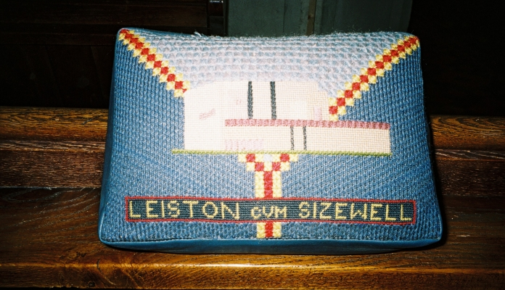

In fact, you don’t have to visit the Cathedral to see the wonderful kneelers because they can all be viewed online at www.stedscathedral.org We also have a fine selection of kneelers here at St. Margaret’s which can be viewed and used. This will be, of course, once covid-19 restrictions are relaxed!

Sandra Harle

Grace reports on her time on the Suffolk Historic Churches Trust Ride and Stride this year.

Terri Roper and Paul Marshall also took part in the Ride and Stride and the total amount raised, which will be shared between St Margaret’s Church and the Suffolk Historic Churches Trust will be given in next month’s magazine.

Kids Zone
Welcome to ‘your page’ Activities to enjoy!
This month a word search

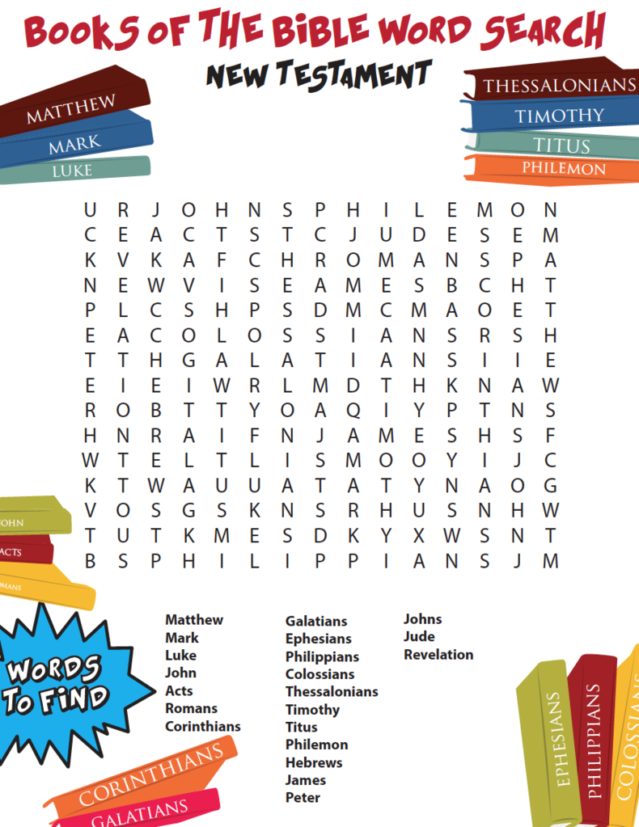

Quiz
- What is the last word in the Old Testament?
- By which previous name was Paul of Tarsus known as?
- Whose wife was turned into a pillar of salt when she looked back?
- In the bible, who is said to have lived on a diet of locusts and wild honey?
- How many years did Noah live for after the flood?
- There are only three angels named in the bible, Michael and Lucifer are two, name the other?
- The book of Esther is unique because it does not mention which word?
- The Bible was written in 3 languages - Hebrew, Koine Greek and which other language?
- Who made the first translation of the Bible into English in 1382?
- Name the longest book of the Bible with 150 chapters?
- In what city was Jesus born?
- Who took the place of Judas in the twelve disciples?
- Who was the older brother of Moses?
- What kind of wood was Noah's ark built from?
- Who, following Moses' death, became the leader of the children of Israel?

Answers next month

PLEASE NOTE: Andrew Hawes no longer uses
Mobile number 07521476294
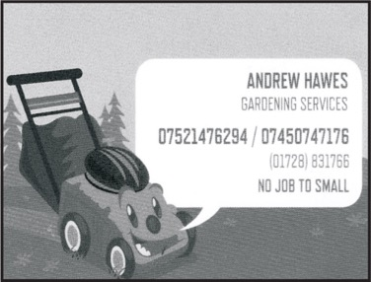
CARLTON FOOTCARE
Sarah Shingfield Foot Health Practitioner MCFHP MAFHP
Offering Clinic visits or Home visits
Call Sarah on 07725215856

Has own clinic in Carlton, Saxmundham or happy to visit in client’s home
Fully insured, DBS checked and registered member of
British Association of Foot Health Professionals

CARLTON FOOTCARE
Sarah Shingfield Foot Health Practitioner MCFHP MAFHP
Offering Clinic visits or Home visits
Call Sarah on 07725215856

ST MARGARET’S CHURCH TOWER LIGHTS UP
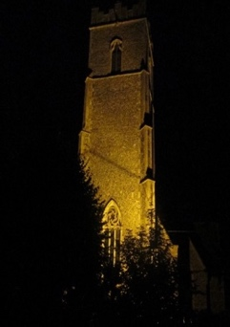
During September the lighting of the Church Tower was sponsored on:

Sunday 6th Remembering Gladys Sexton, Rose Clark and John Walker. Three dear friends who shared the same birthday. V Matthews

Sunday 6th Happy Birthday John (Bartholomew)
With love from all the family

Tuesday 8th Thinking of Ena, a mum, nan and great nan on what would have been her 94th birthday.
With love from Nick, Andrea and Caitlin and Dene, Cees and families.

Friday 11th In memory of our dear friend Betty. Still missing you.
Love Margaret & Bill xx

Saturday 12th In memory of my dad Ernest Roper.
With love from Terri

*If you would like to mark a special occasion by sponsoring the lighting of the Church Tower for a donation of £5 per day, please write the details in the diary provided in church, then place the completed payment envelope in the wall safe. Many thanks.

*If you would like to arrange to light the tower during the lockdown period, please contact Sandra (contact details page 2)

Special Prayers
David Liz

(Corrected entry) Wedding

Saturday 22 August 2020
Jason Slaymaker and Kelly Sweetland

Funerals
1 September Molly Blanche Grace Bloss
11 September Walter Robert Cornish (Robin)
14 September Philip Robert Clarke

MR AND MRS TIGGYWINKLE – THE CONTINUING STORY

Last month I write about my hedgehog feeding station and my nocturnal visitors as recorded on my wildlife trail camera. I am still putting out hedgehog food and water each night and my visitors continue to come.

Recently a friend showed me a photograph of an object another friend had found in the garage of her son’s new home. Did I know what it was? I certainly did – it was a hedgehog house. Would I like it? Yes, most certainly I did. I went the next day and collected it. I plan to fill it with dried leaves and to place it in the shelter of the trees down the side of my garden. And then it will be a waiting game to see I can tempt a family to settle in my garden. And hoglets in the spring – we shall have to wait and see ........

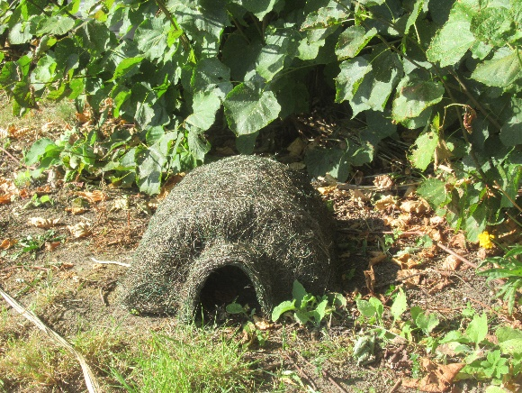

Work – Walk – Eat – Sleep – Repeat!

Even though we are unable to actually work together in our office, my
colleagues at BT Martlesham decided that we should take part in a charity
challenge to give us all something to focus on. St. Elizabeth’s Hospice normally
organises the annual Midnight Walk but, due to current restrictions, this year’s
event had to be cancelled. In its place, the Virtual Walk took place from 19 th -
26 th September.

Those from my team taking part split into two teams to compete against each
other, to see who could walk the furthest and who could raise the most
money. Lockdown has resulted in new ways of thinking, people taking better
care of themselves and also looking out for others. Scientists have proved that
even a ten minute walk immediately boosts brain chemistry to increase
happiness. I am pleased to report that my team took on the challenge and
have walked much further than we ever thought we would, raising funds for
our local Hospice along the way.

At the end of the week, we have raised a total of £225 and walked over 550KM, equivalent to 341 miles!

Check out these selfies from some of my team, one featuring Phill and his
lovely dog, Zeus! Zeus has definitely earned a nice rest and a new toy after this
hard week of walking. The other photo is of another member of my team
called Andy, who has captured a very picturesque scene near where he lives in
Mickfield.
Onto the next team adventure!

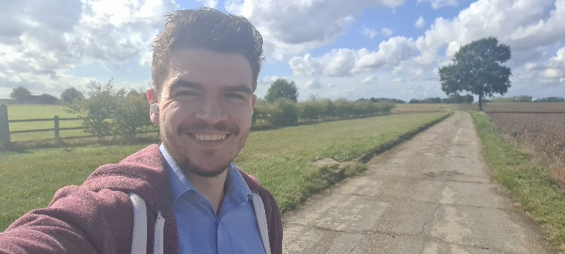

Ellie Harle

The Win and the Willow
Over lockdown we have been appreciating the company and entertainment
provided by our pets. About four years ago Willow, the cat, decided to make our house her new home. She has become a much loved member of the family, has found lots of ingenious hiding places around the house and has been spoiled rotten with an endless supply of ‘Dreamies’.

During lockdown I received several emails about various ‘virtual’ fundraising
events, and one that caught my interest was a ‘Pet Pageant’ being organised
by St. Elizabeth’s Hospice. There were six categories and Willow, together with
our rabbit Toffee, fitted into two of them – Favourite Furries and Mirror Image.
I submitted two pictures to Favourite Furries, one of Willow and one of Toffee.
We have always taken lots of pictures of our pets and I had a perfect entry for
the Mirror Image category as well. It was a fun and easy way to help the Hospice raise much needed funds.

A month later I received an email from the organisers telling me that Willow
had won the Mirror Image category. Our prize was a voucher for Jolly’s Pet
Store in Ipswich, which has been exchanged for some new catnip toys and lots
more Dreamies! The certificate has been laminated and takes pride of place on the fridge door, while Willow is now known as ‘The Prize Winning Kitty’. Clearly, every cat has their day too. The Hospice raised over £300 in their first ever pet pageant, which is brilliant!

There is now a whole year to keep working on our photography skills so that
we can enter again next year.

Well done Ellie and Willow of course!!
*************************************************************
THE LITTLE PRINCESS TRUST
THANK YOU
Thank you to everyone who contributed towards The Little Princess Trust for which I have been fundraising. The final total raised was £500! I was so pleased with the result and I have been overwhelmed by the support I have received.

Imogen Claydon

******************************************************************************
The Children’s Society – Box Collections
In the last few days I have received notification from The Children’s Society that the box collection scheme can be resumed, and I now have the information and resources I need to process your kind donations and to re-issue the boxes.

I would, therefore, be most grateful if you could let me have your boxes as soon as possible, either at church or at my home address (4 Lime Tree Avenue) or, if you’d prefer, I’m more than happy to collect from you – please ring me on 833578.

Many thanks,
Sandra Harle.

A message from The Children’s Society’s regional manager for our area.
I hope that however you’ve been supporting us, you realise just how much you’re doing for young people who are struggling right now. Thanks to you, we’ve been able to stay in touch with children isolated by the lockdown, to let them know things will be ok. We’ve been able to get food through to families who suddenly found themselves with no source of income. We’ve been able to make sure the most at risk children could stay safe. That’s the difference you’re making, and it’s hard to overstate how much everyone here appreciates what you do.

ST MARGARET’S CHURCHYARD
In July 2019 the Parochial Church Council began discussing the management of our churchyard in such a way to encourage wildlife and plant diversity. Following some discussion it was agreed to take this forward taking into consideration a paper put forward by the Suffolk Wildlife Trust and with the agreement of the Diocese.

Many churchyards have escaped the agricultural development which causes the loss of semi-natural habitat seen elsewhere. Churchyards can be important for wildlife, providing a refuge for a wide range of wildflowers, birds, animals and invertebrates. By leaving some designated areas to be un-mown the native wildflowers that still survive in these relatively unimproved soils will flower and set seed. This will help enhance the botanical diversity within the churchyard and also provide an important source of nectar for bees and butterflies throughout the summer months. The invertebrate life associated with the increased botanical and structural diversity of these areas will in turn provide food for a range of birds and mammals such as swifts, hedgehogs and bats. Careful management of all or part of the churchyard to favour these flowers offers a unique opportunity to safeguard this valuable habitat in a place where it can be enjoyed by all.

Our churchyard is in the care of East Suffolk Council and Paul Tynan (Council land management services) in charge of our churchyard has agreed a new cutting regime which will enhance the diversity. The grassland needs to be cut and the clippings removed. Cutting has to be timed to allow the grasses and other species to flower and set seed. Pathways will continue to cut through the grass to enable access to all parts of the churchyard. The part of the churchyard alongside Church Road to the north of the church is the area which has initially been identified for the new mowing programme.

Unfortunately Covid-19 has caused a slight stop to this new programme. Staff shortages have meant that the Council has been doing smaller amounts of maintenance work in all the churchyards under its care. It is to be hoped that next year the new mowing pattern can be followed to make a start to our revised plans.

It is hoped that from May through to August the wildflower areas will provide a rich display of colour and the ongoing management will be targeted towards promoting the re-establishment of the wildflower area for the benefit of biodiversity.

Hopefully monitoring of the wildflower area over the coming years will show how positive management improves biodiversity.

ST. MARGARET’S CHURCH FAMILY

INTERCESSION PRAYERS FOR OCTOBER 2020

Dear Friends

October’s magazine continues to focus on monthly prayer time, with the St Margaret’s Church family group for this month as shown below. There are three family groups with each one appearing in the magazine every three months. However, you remain in our thoughts and prayers always.
If you would like to be included in our family monthly prayers, or have any queries please email stmargaretsleiston@gmail.com. If you feel you would prefer to be remembered in a particular month then please let us know. Also, if you have a specific need for additional prayer time then please let us know and we will add you to our ‘special prayers’ section.

In our Church Family Prayers

Jim & Pauline Florance  Bernard & Patsy Smith  Joe Diegnan  Pat, Neil, Lucy, Craig & Ryan Carter  Daryl, Helen & Chloe Cartley  John and Joy Kemp  Mary Joel  Kate Kersey  Peter Downey  Donna Button  Billy & Margaret Clarke  Lesley Martin  Julie, Ellie & Charlie Howard  Kay, Trevor & Grace Nash  Anthony & Sue Hawkes  Hilary & Richard Slaughter  Toby, Sharon, Emma & Sophie Slaughter  Jill Staff  Glyn & June Clarke  Robin & Mary Cornish  Gladys Stannard  Trevor & Thelma Hawkins  Kirsty Stowe  Rodney Avis | Roy Hubbard  Shirley Newman  Matthew, Vanessa, Alex, Kierah & Sasha Newman  Kathryn, Mark, Ian & Stuart Langley  Adrian & Jackie Shotter  Stephanie, Craig, Isla & Edie Shotter  Kim, Dan & Indi Rose Keeble  Jan Snowden  Nicola, Jon, Toby, & Robert Kerridge  Josie, Steven, Olivia & Maisie Snowden  Derek & Barbara Cole  June Linsell  Hilda Woodhead  Pat & John Swatton  Debbie, Samantha & Matthew Vettesse  Kay Curtis  Colin, Lucy, Freya, Lola & Leeam Curtis  Nicola, Matthew, Callum & Jamie Smy  David, Lisa, Isle & Neave Curtis  Elaine & Jon Ellis  Norman Chapman  Eamonn, Cathy & Ursula Harvey  Helen Thackeray
St Margaret of Antioch

Parish Church of Leiston-cum-Sizewell

Church Road, Leiston, Suffolk IP16 4HG

NOTICE: Items for November’s magazine
Please note that all articles, adverts etc. will need to be submitted to Pat Carter by 18 October for inclusion in the November Magazine. Thank you.

Email: pm42carter@gmail.com
The Parish Magazine is available from St Margaret’s Church. Delivery can be arranged.

Keep up to date with all Church Events
By visiting our own website
www.stmargaretschurchleiston.onesuffolk.net

How to Find Us
